1. **Create a graph with 2 vectors**

#Define 2 vectors

cars <- c ( 1, 3, 2, 4, 5)

trucks < - c( 2, 5, 4, 5, 1)

#Graph cars using a y axis that ranges fron 0 to 5

plot(cars, type=”o” , col=”blue” , ylim=c(0,5))

#Graph trucks with red dashed line and square points

lines(trucks, type=”o” , pch=22, lty=2, col=”red

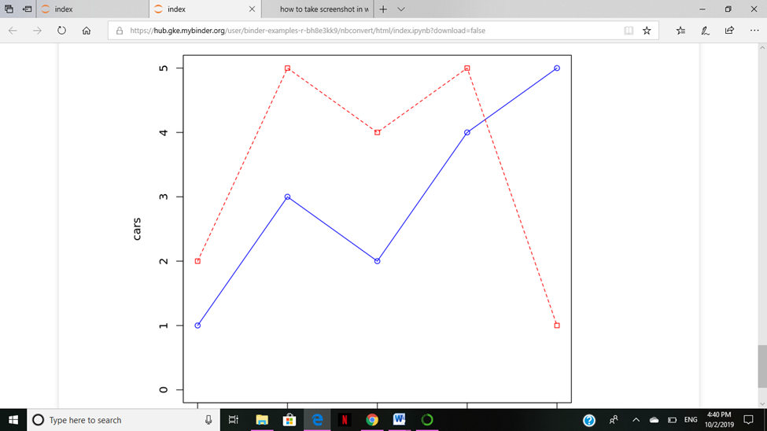

**2 . Explain about the probability distribution and execute normal distribution in R**

**Probability distribution:**

A probability distribution is a statistical function that describes all the possible values and likelihoods that a random variable can take within a given range. This range will be bounded between the minimum and maximum possible values, but precisely where the possible value is likely to be plotted on the probability distribution depends on a number of factors. These factors include the distribution's mean (average), standard deviation , skewness, and kurtosis

**Normal Distribution in R**

In a random collection of data from independent sources, it is generally observed that the distribution of data is normal. Which means, on plotting a graph with the value of the variable in the horizontal axis and the count of the values in the vertical axis we get a bell shape curve. The center of the curve represents the mean of the data set. In the graph, fifty percent of values lie to the left of the mean and the other fifty percent lie to the right of the graph. This is referred as normal distribution in statistics.

R has four in built functions to generate normal distribution. They are described below.

dnorm(x, mean, sd)

pnorm(x, mean, sd)

qnorm(p, mean, sd)

rnorm(n, mean, sd)

Following is the description of the parameters used in above functions −

**x** is a vector of numbers.

* **p** is a vector of probabilities.
* **n** is number of observations(sample size).
* **mean** is the mean value of the sample data. It's default value is zero.
* **sd** is the standard deviation. It's default value is

**dnorm()**

x <- seq(-20, 20, by = .1)

y <- dnorm(x, mean = 5.0, sd = 1.0)

plot(x,y, main = "Normal Distribution", col = "blue")

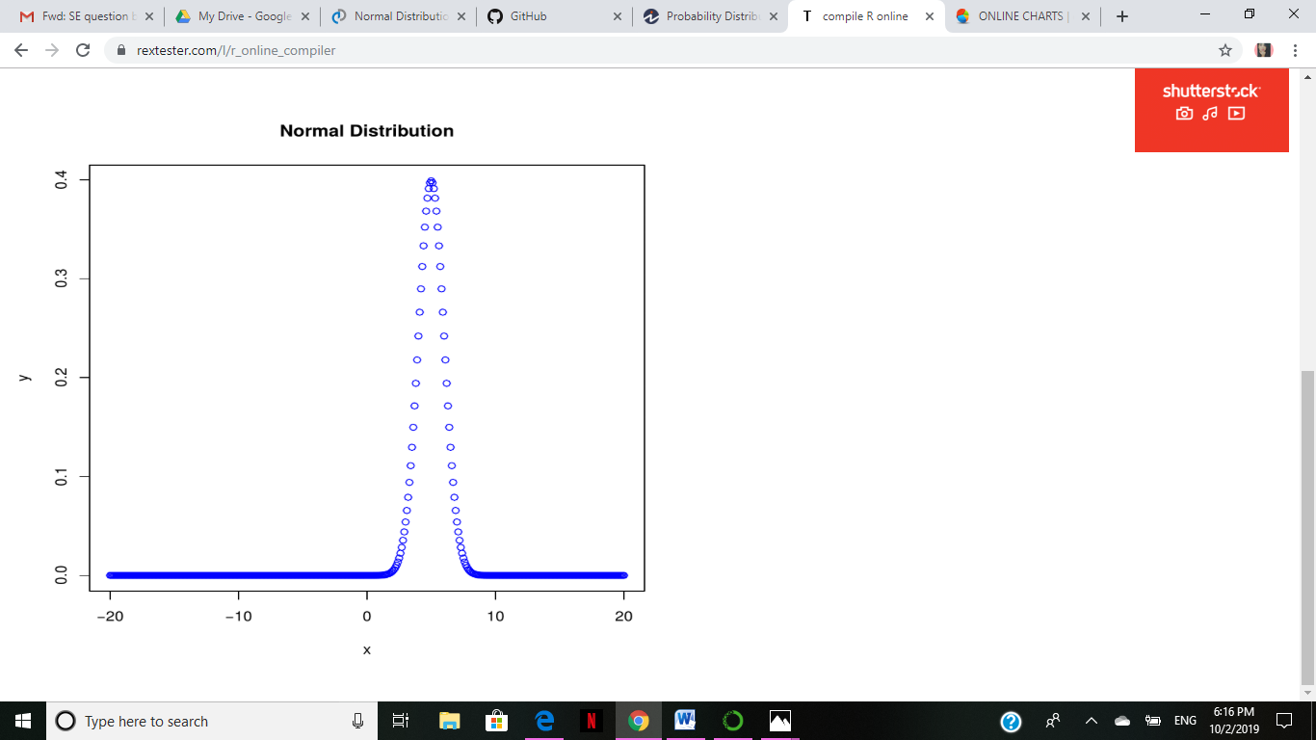

**pnorm()**

x <- seq(-20, 20, by = .1)

y <- pnorm(x, mean = 5.0, sd = 1.0)

plot(x,y, main = "pnorm()", col = "blue")

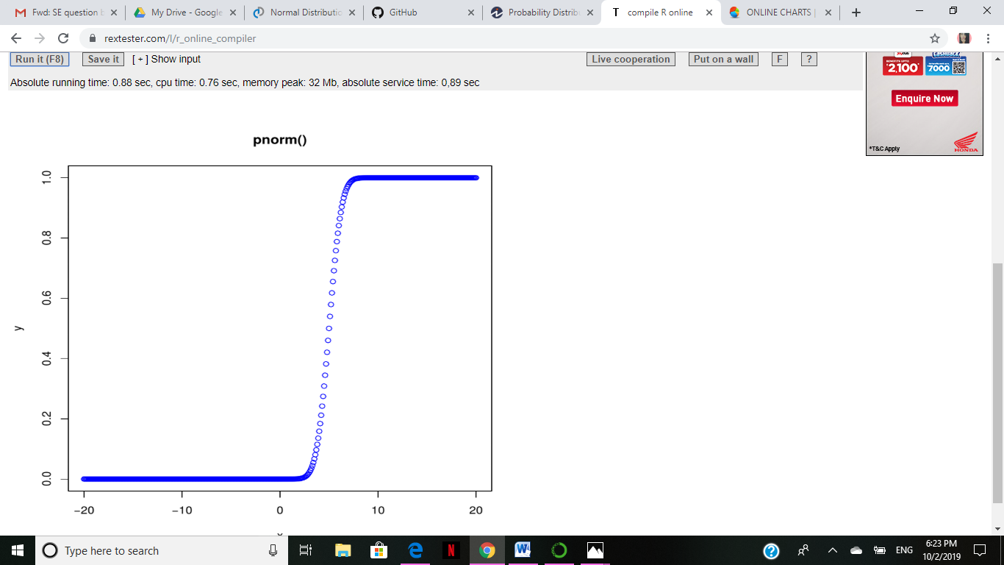

**qnorm()**

x <- seq(0, 1, by = 0.02)

y <- qnorm(x, mean = 2, sd = 1)

plot(x,y, main = "qnorm()", col = "blue")

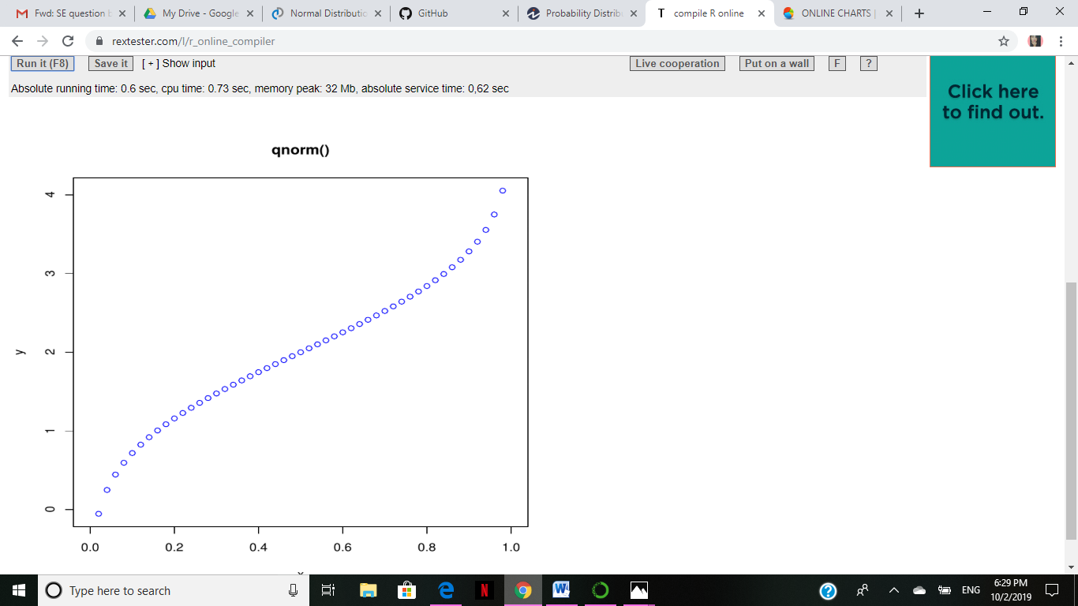

**rnorm()**

y <- rnorm(50)

hist(y, main = "Normal Distribution", col = "darkorange")

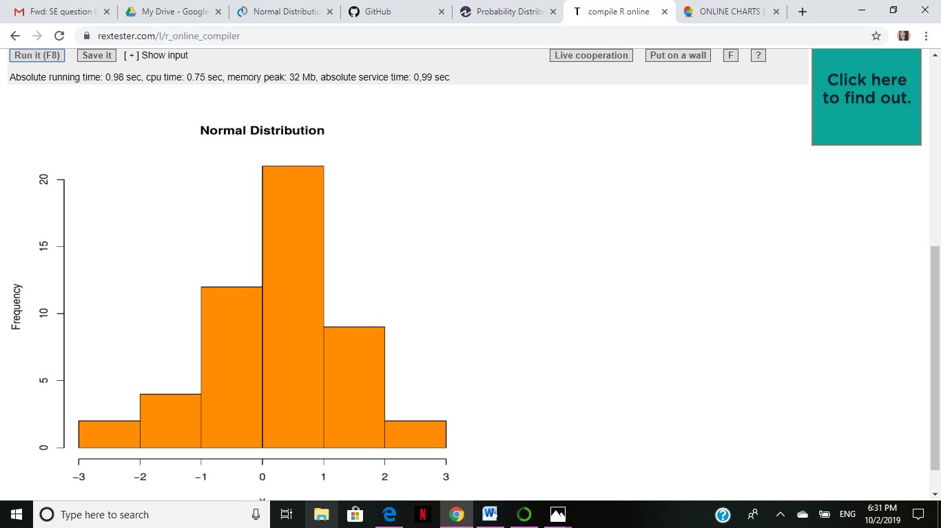

**3.Execute binomial distribution and create histograms with sizes 1 to 10 and prob 0.1 to 0.9 each with n value 10**

**R Binomial Distribution**

The binomial distribution model deals with finding the probability of success of an event which has only two possible outcomes in a series of experiments. For example, tossing of a coin always gives a head or a tail. The probability of finding exactly 3 heads in tossing a coin repeatedly for 10 times is estimated during the binomial distribution.

R has four in-built functions to generate binomial distribution. They are described below.

dbinom(x, size, prob)

pbinom(x, size, prob)

qbinom(p, size, prob)

rbinom(n, size, prob)

Following is the description of the parameters used −

* **x** is a vector of numbers.
* **p** is a vector of probabilities.
* **n** is number of observations.
* **size** is the number of trials.
* **prob** is the probability of success of each trial.

**dbinom()**

# Create a sample of 50 numbers which are incremented by 1.

x <- seq(0,50,by = 1)

# Create the binomial distribution.

y <- dbinom(x,50,0.5)

# Give the chart file a name.

png(file = "dbinom.png")

# Plot the graph for this sample.

plot(x,y)

# Save the file

dev.off()

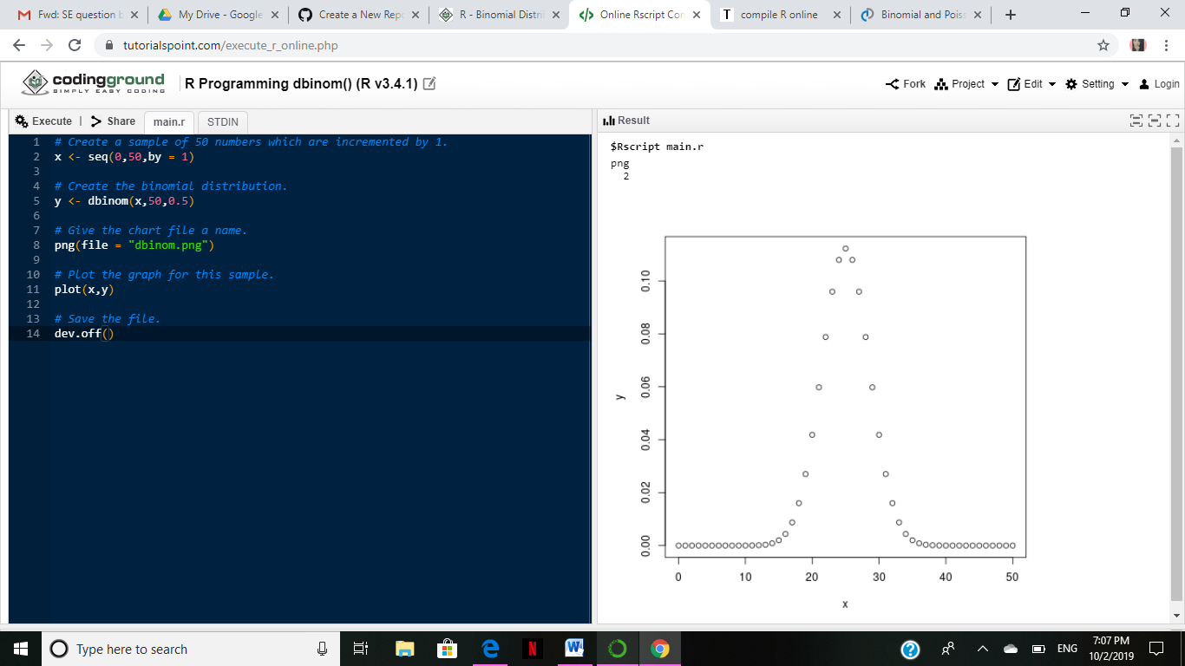

**pbinom()**

Probability of getting 26 or less heads from a 51 tosses of a coin.

x <- pbinom(26,51,0.5)

print(x)

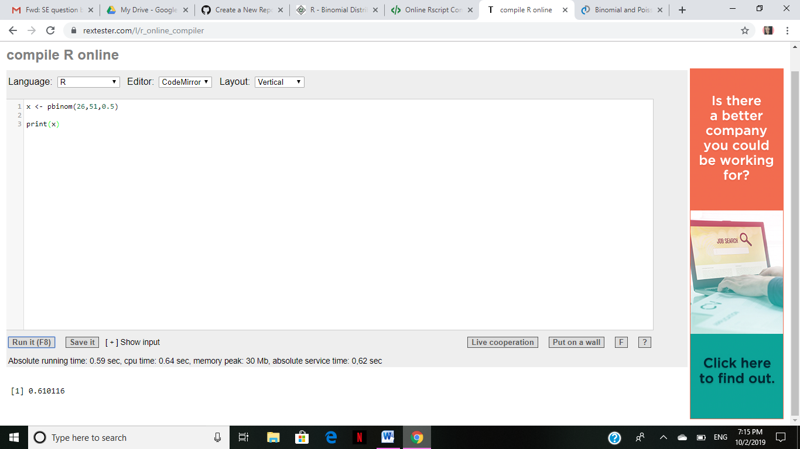

**qbinom()**

# How many heads will have a probability of 0.25 will come out when a coin

# is tossed 51 times.

x <- qbinom(0.25,51,1/2)

print(x)

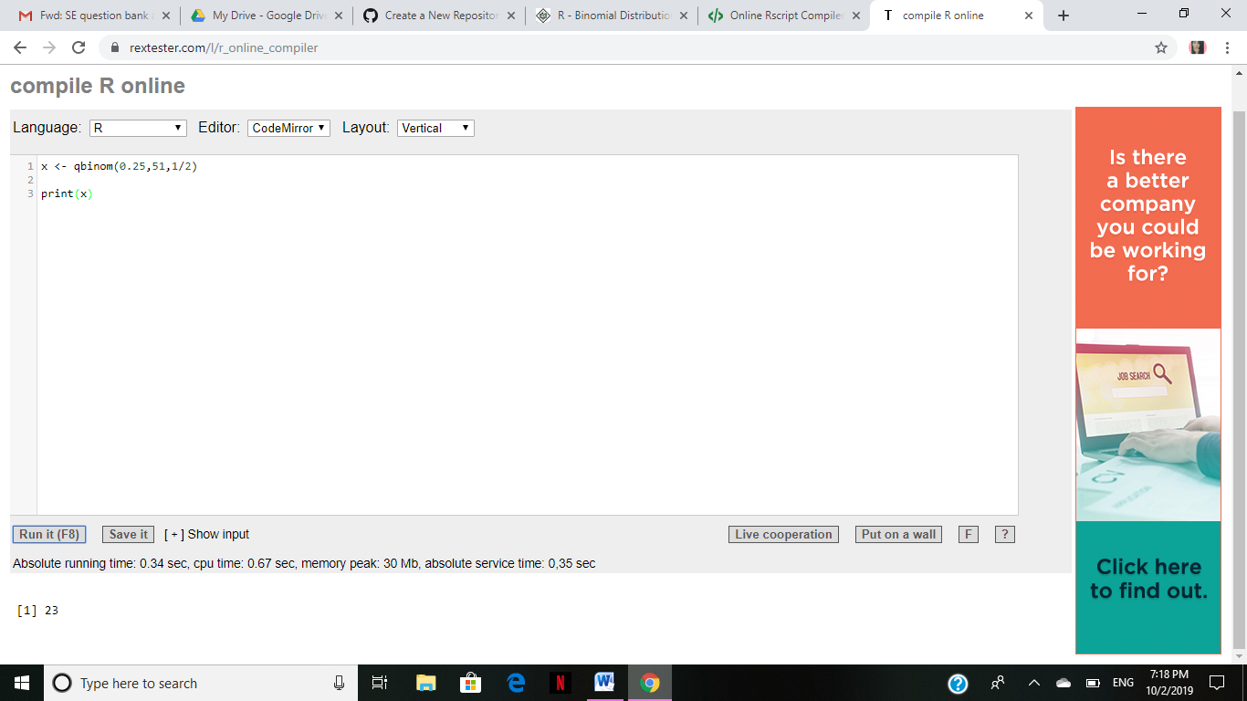

**rbinom()**

# Find 8 random values from a sample of 150 with probability of 0.4.

x <- rbinom(8,150,.4)

print(x)

